# Experiment No.: 7

**Control Valves**

Cut-section, accessories, actuators and various types of valves

|  |  |
| --- | --- |
| **Academic Year** | **: 2021-22 Sem : I** |
| **Class** | **: TY BTech Instrumentation & Control** |
| **Course Name** | **: Process Instrumentation** |
| **Course Code** | **: IC3231** |
| **Name** | **: Shaunak Deshpande** |
| **Division** | **: IC-C** |
| **Roll No.** | **: 39** |
| **G.R. No.** | **: 11911180** |

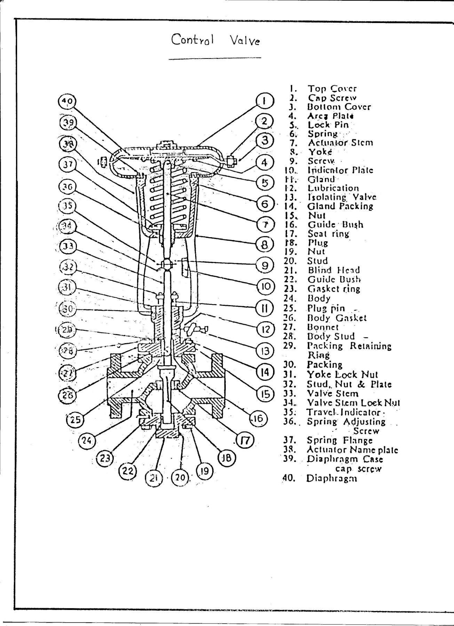

**Experiment No. 7**

**Control Valves**

**Aim :** To Study of control valve cut section, accessories, actuators and various types of valves.

**Apparatus :** Control Valve cut-sections, actuators and various types of valves, etc.

### Theory :

A control valve is a pressure dropping device, which is used to regulate the flow rate I a fluid delivery system according to the control signal. In general a close relation exists between the pressure along a pipe and the flow rate so that if pressure is changed then the flow rate is also changed. A control valve changes flow rate by changing the pressure in flow system. The flow rate through the restriction is given by:

Q = k(p2-p1)^1/2

Where k is proportionality constant.

The constant k depends on the size of the valve, the geometric structure of the delivery system and to some extent on the material flowing through the valve opening changes flow rate, it provides a mechanism of flow control.

Input : stem position (0-100%) Output : flow rate (0-100%)

**Working :**A reverse acting actuator is designed do that air pressure below the diaphragm moves the stem upward opening the valve. This action is termed as air to open.

Here valve is direct acting type i.e. push down to close. So actuator is reverse type and the valve is direct type.

### Specifications :

Make :Dembla

Type : Globe valve two way Size : 15mm

Body : cast steel Trim : SS 316

Packing :PTFE (Teflon) + ABS (Asbestos) Plug Characteristics : Equal Percentage

Cv : 0.5 gpm

Stroke length : 18mm

Actuator : Pneumatic Spring and diaphragm type Action : Air to open

Valve : Direct, Push down to close Fail safe : Air failure to close Spring Range : 02 to 1 Kg/cm2

Max. change in pressure : 3.5 Kg/cm2 Process connection Rating : ANSI 150

**Control valve applications:**

1. **Butterfly valve**: In the pharmaceutical, chemical and food industry a butterfly valve is used to interrupt product flow (solid, liquid, gas) within the process. The valves used in these industries are usually manufactured according CGMP guidelines (current good manufacturing practice )
2. **Ball valve**: Pulp & paper industry uses ball valve. It is also used as shut-off valve. ball valve includes a wide selection of solutions for dependable isolation in power mining, refining, silica and petrochemical applications.
3. **Globe valve**: They are used to control flow rates when mixed fluids are there or in batching operations where fluid flow is continuously adjusted. It is used oil and gas industries and for regulating flow.
4. **Gate valve**: They are used when straight line flow of fluid and minimum restrictions are needed. It is also used paper and pulp industry, slurry handling, water and sewage, high temperature.
5. **Pneumatic valve**: it is used in transportation industry in the suspension and engine of transportation. Also used in utility equipment.
6. **Diaphragm valve**: These valves are used on shut-off and throttling service for liquids. Used for slurries, vacuum, gases and to isolate or block flow.
7. **Plug valve**: these are used for On-off control on flow. For moderate flow throttling and for flow diversion using multiport valves.
8. **Needle Valve** : Generally used for air / gas service and also for very accurate flow control applications.

**Screenshots of the Tasks completed on the Virtual Lab:**

(Theory, Pre-Test, Component Identification, Simulation – Test, Sizing steps, Post Test, etc.)

Theory:

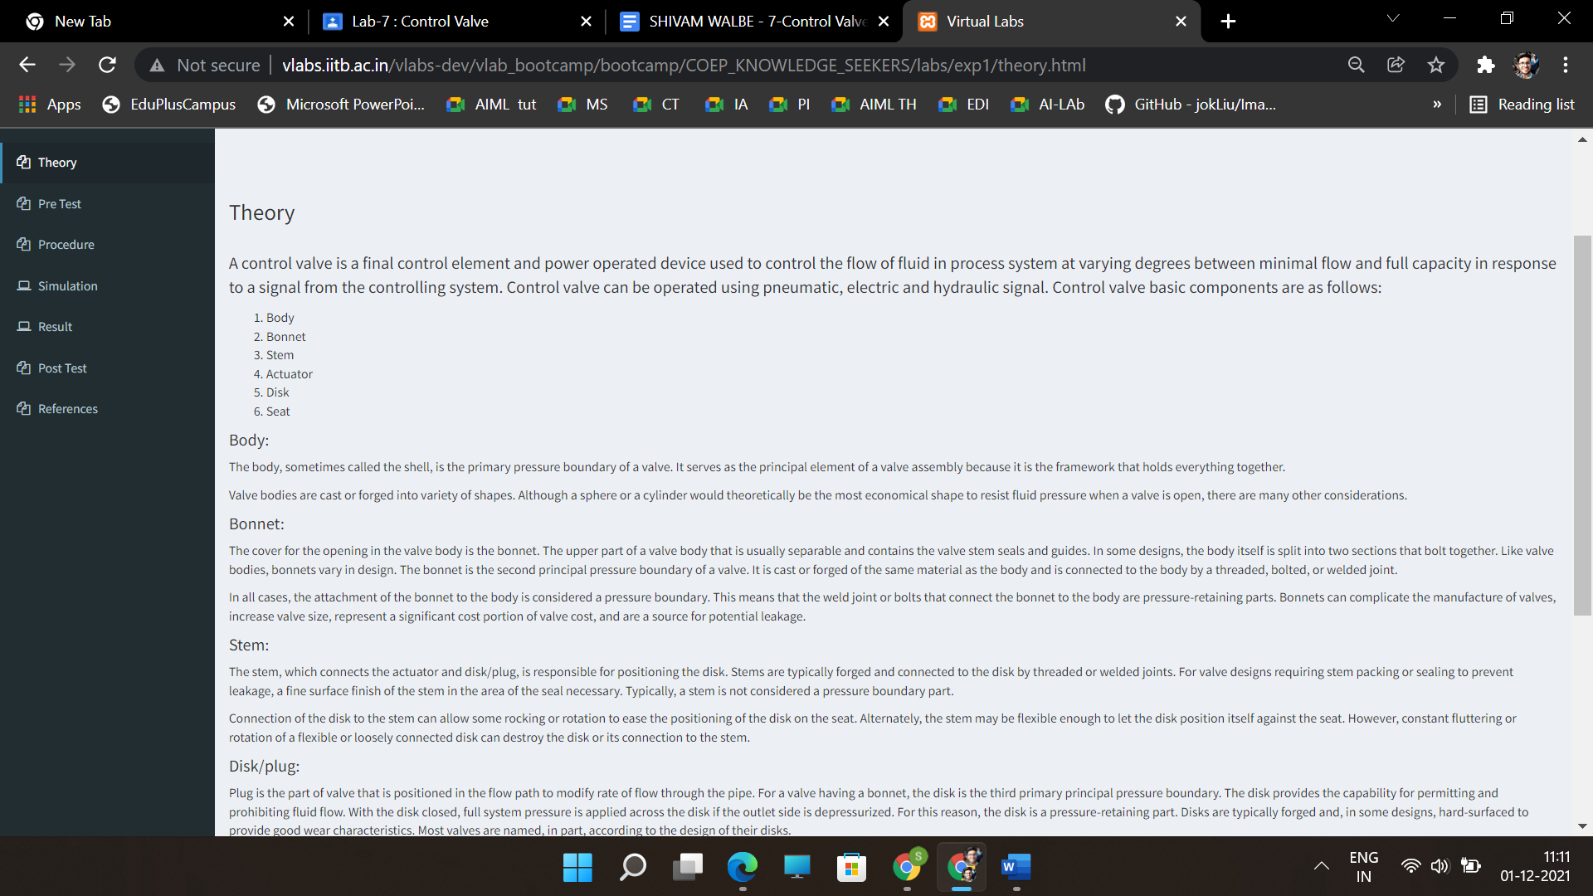

Pre-test:

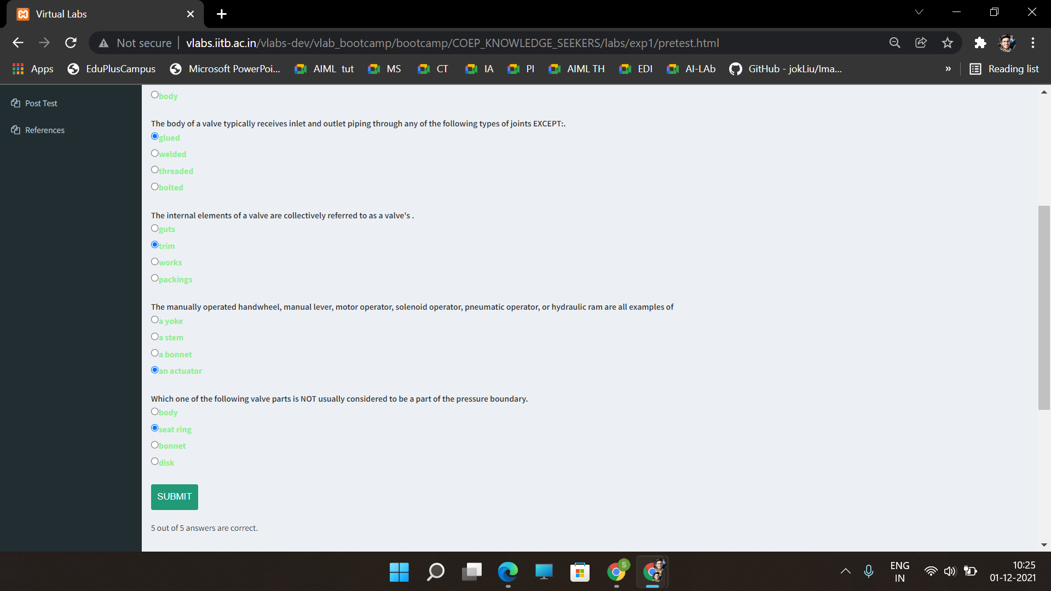

Component Identification:

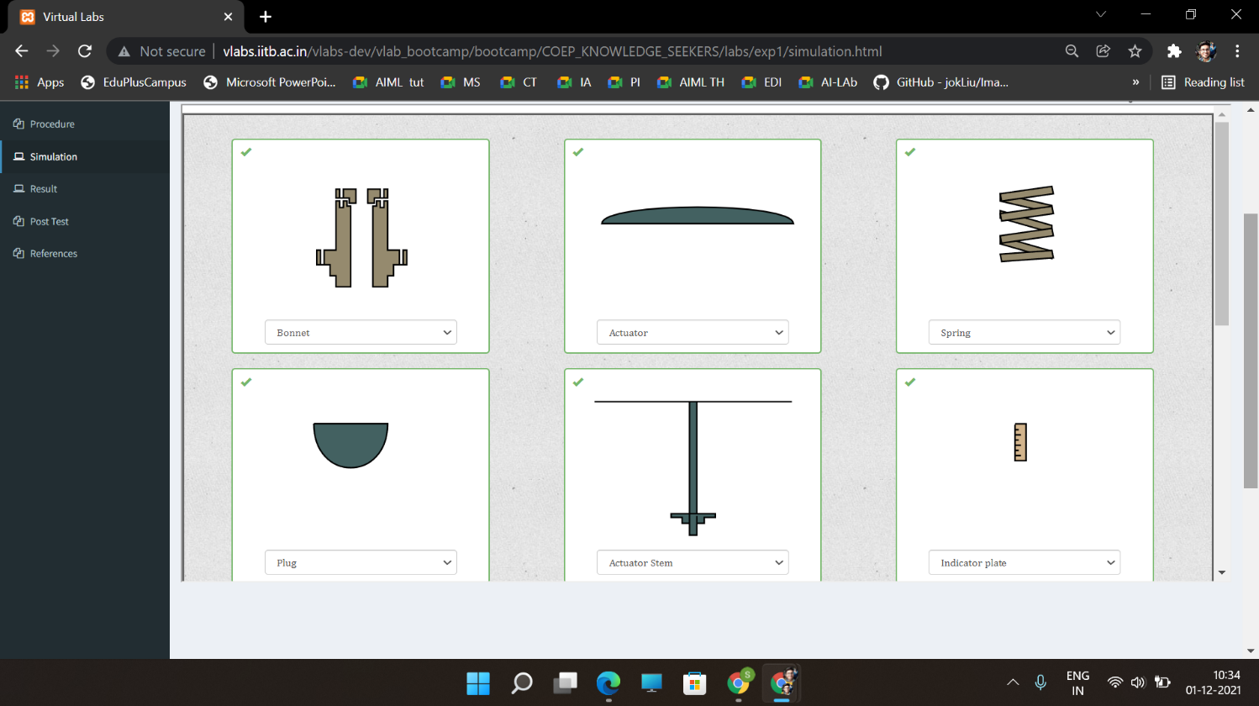

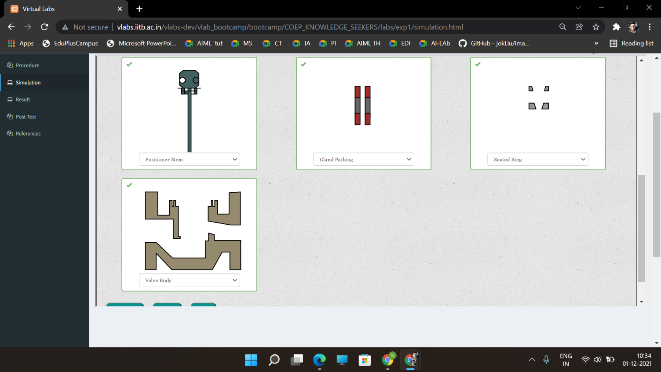

Simulation:

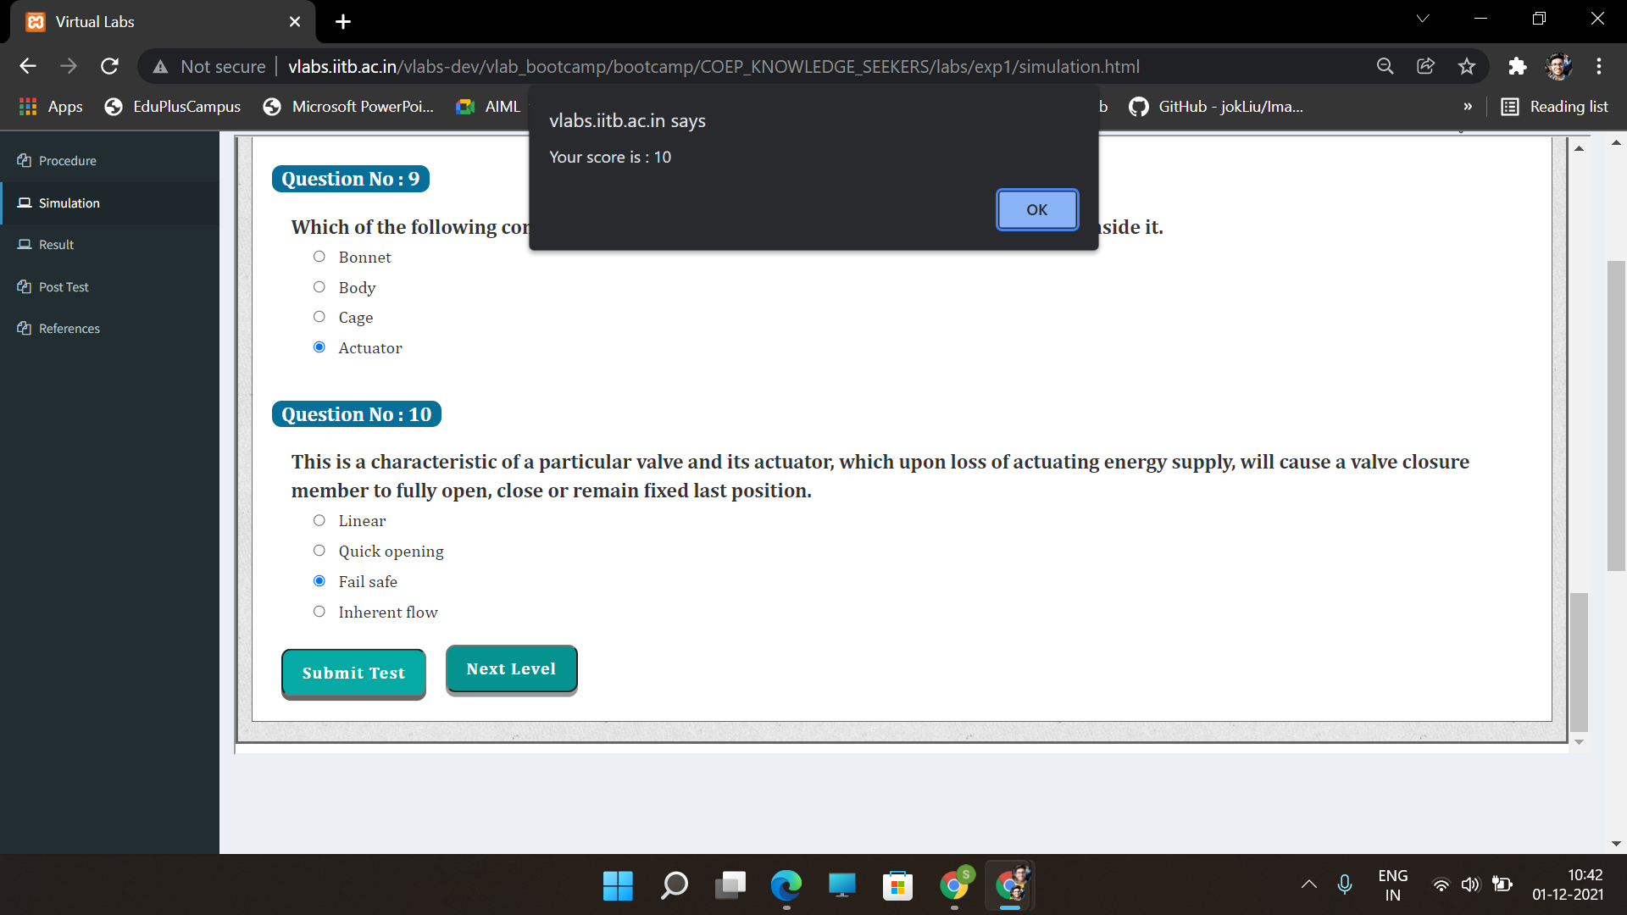

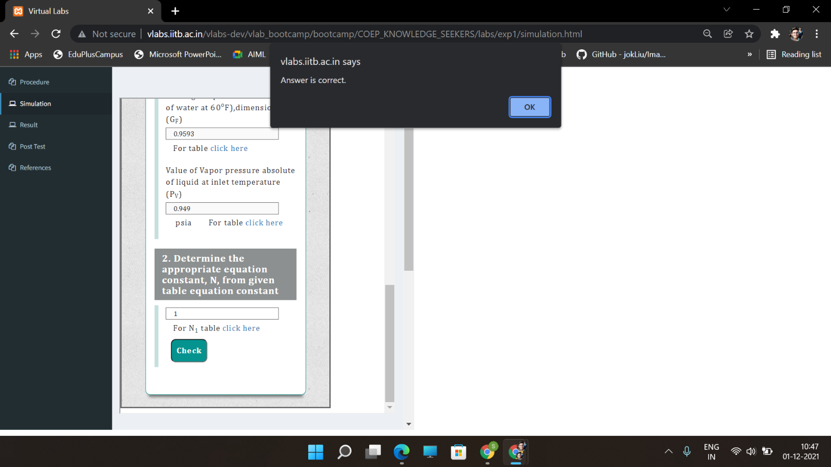

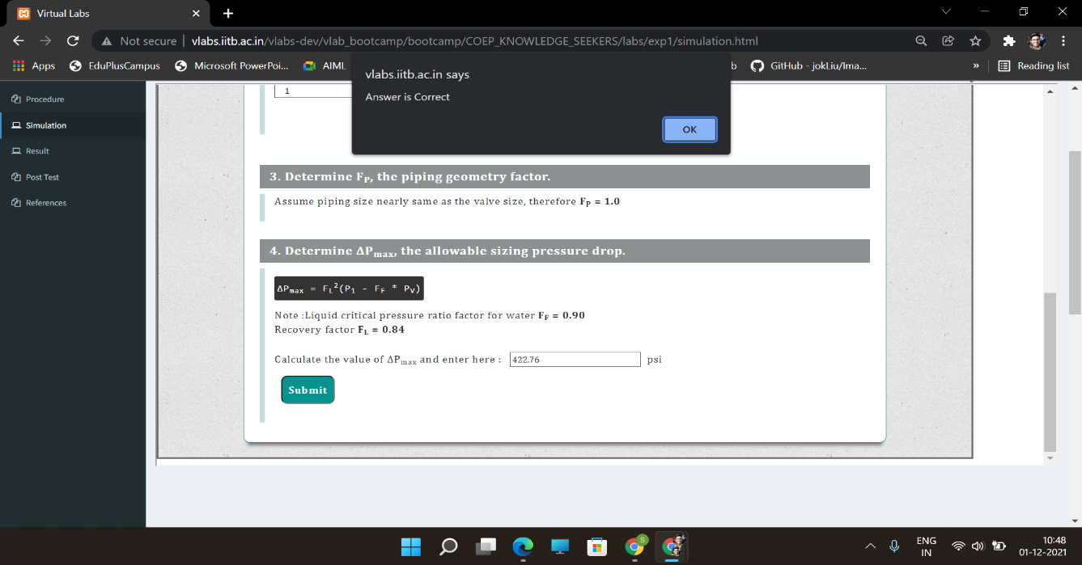

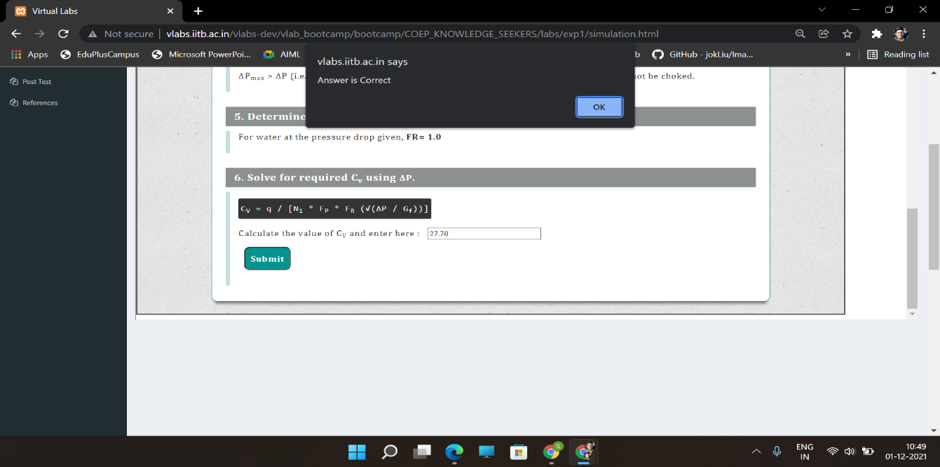

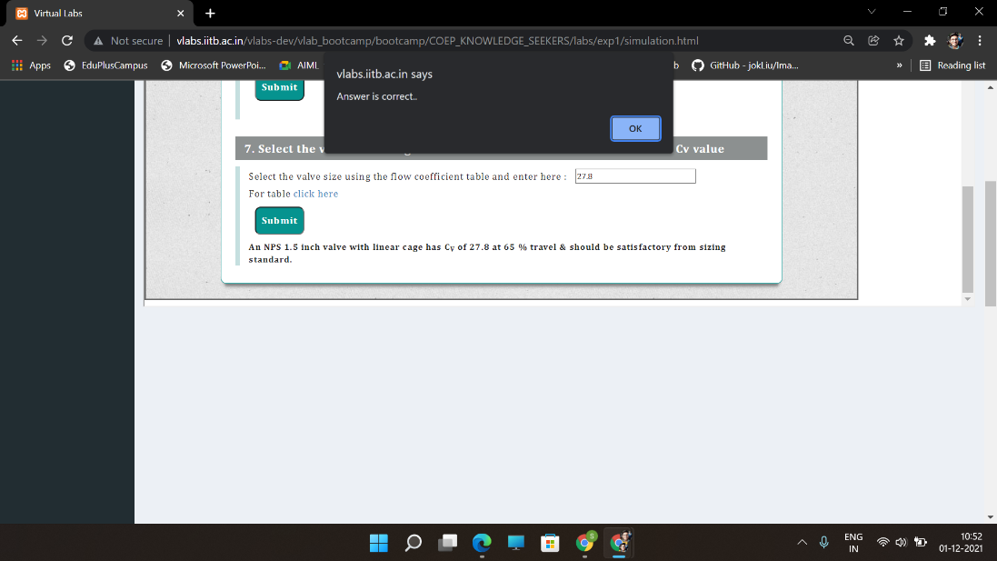

Post-Test:

